**ANTENNA AND ITS TYPES**

Antennas are basic components of any electrical circuit as they provide interconnecting links between transmitter and free space or between free space and receiver. Before we discuss about antenna types, there are a few properties that need to be understood. Apart from these properties, we also cover about different types of antennas used in communication system in detail.

**Properties of Antennas**

* Antenna Gain
* Aperture
* Directivity and bandwidth
* Polarization
* Effective length
* Polar diagram

**Antenna Gain:** The parameter that measures the degree of directivity of antenna’s radial pattern is known as gain. An antenna with a higher gain is more effective in its radiation pattern. Antennas are designed in such a way that power raises in wanted direction and decreases in unwanted directions.

**G =   (power radiated by an antenna)/(power radiated by refernce antenna)**

**Aperture:** This aperture is also known as the effective aperture of the antenna that actively participate in transmission and reception of electromagnetic waves. The power received by the antenna gets associated with collective area. This collected area of an antenna is known as effective aperture.

**Pr = Pd*A watts**  
**A=pr/ pd m2**

**Directivity and Bandwidth:** The directive of an antenna is defined as the measure of concentrated power radiation in a particular direction. It may be considered as the capability of an antenna to direct radiated power in a given direction. It can also be noted as the ratio of the radiation intensity in a given direction to the average radiation intensity. Bandwidth is one of the desired parameters to choose an antenna. It can be defined as the range of frequencies over which an antenna can properly radiates energy and receives energy.

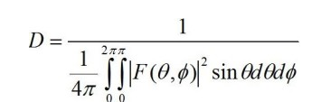

**Polarization:** An electromagnetic wave launched from an antenna may be polarized vertically and horizontally. If the wave gets polarized in the vertical direction, then the E vector is vertical and it requires a vertical antenna. If vector E is in horizontal way, it needs a horizontal antenna to launch it. Sometimes, circular polarization is used, it is a combination of both horizontal and vertical ways.

[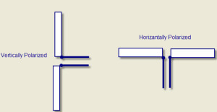](https://www.elprocus.com/wp-content/uploads/2014/07/polarization.jpg)

**Effective Length:** The effective length is the parameter of antennas that characterizes the efficiency of the antennas in transmitting and receiving electromagnetic waves. Effective length can be defined for both transmitting and receiving antennas. The ratio of EMF at the receiver input to the intensity of the electric field occurred on the antenna is known as receivers’ effective length. The effective length of the transmitter can be defined as the length of the free space in conductor, and current distribution across its length generates same field intensity in any direction of radiation.

**Effective Length = (Area under non-uniform current distrbution)/(Area under uniform current distribution)**

**Polar diagram:** The most significant property of an antenna is its radiation pattern or polar diagram. In case of a transmitting antenna, this is a plot that discusses about the strength of the power field radiated by the antenna in various angular directions as shown in the plot below. A plot can also be obtained for both vertical and horizontal planes – and, it is also named as vertical and horizontal patterns, respectively.

[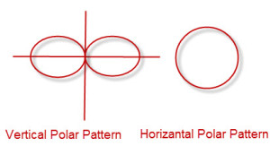](https://www.elprocus.com/wp-content/uploads/2014/07/polar-diagram.jpg)

Till now we have covered the properties of antennas, and now we will discuss on different types of antennas that are used for different applications.

## Types of Antennas

Log Periodic Antennas

* Bow Tie Antennas
* Log-Periodic Dipole Array

Wire Antennas

* Short Dipole Antenna
* Dipole Antenna
* Monopole Antenna
* Loop Antenna

Travelling Wave Antennas

* Helical Antennas
* Yagi-Uda Antennas

Microwave Antennas

* Rectangular Micro strip Antennas
* Planar Inverted-F Antennas

Reflector Antennas

* Corner Reflector
* Parabolic Reflector

### ****1. Log-Periodic Antennas****

[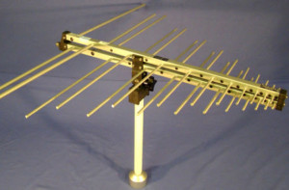](https://www.elprocus.com/wp-content/uploads/2014/07/log-periodic-antenna-Copy.jpg)Log Periodic Antenna

A log-periodic antenna is also named as a log periodic array. It is a multi-element, directional narrow beam antenna that works on a wide range of frequencies. This antenna is made of a series of dipoles placed along the antenna axis at different space intervals of time followed by a logarithmic function of frequency. Log-periodic antenna is used in a wide range of applications where variable bandwidth is required along with antenna gain and directivity.

**Bow-Tie Antennas**

[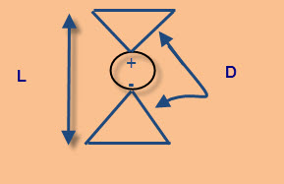](https://www.elprocus.com/wp-content/uploads/2014/07/bow-tie-antenna.jpg)Bow Tie Antenna

A bow-tie antenna is also known as Biconical antenna or Butterfly antenna. Biconical antenna is an omnidirectional wide-band antenna. According to the size of this antenna, it has low- frequency response, and acts as a high-pass filter. As the frequency goes to higher limits, away from the design frequency, the radiation pattern of the antenna gets distorted and spreads.

Most of the bow-tie antennas are derivatives of biconical antennas. The discone is as a type of half-biconical antenna. The bow-tie antenna is planar, and therefore, directional antenna.

**Log-Periodic Dipole Array**

[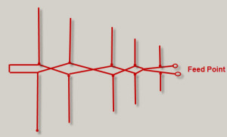](https://www.elprocus.com/wp-content/uploads/2014/07/log-periodic-dipole-antenna.jpg)Log Periodic Dipole Antenna

The most common type of antenna used in [wireless communication technology](https://www.elprocus.com/what-is-zigbee-technology-architecture-and-its-applications/) is a log-periodic dipole array fundamentally comprises a number of dipole elements. These dipole-array antennas reduce in size from the back end to the front end. The leading beam of this RF antenna comes from the smaller front end.

The element at the back end of the array is large in size with the half wavelength operating in a low-frequency range. The spacing of the element gets reduced towards the front end of the array wherein the smallest arrays are placed. During this operation, as the frequency varies, a smooth transition takes place along the array of the elements, which leads to form an active region.

### ****2. Wire Antennas****

[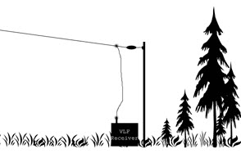](https://www.elprocus.com/wp-content/uploads/2014/07/wire-antenna.jpg)Wire Antenna

Wire antennas are also known as linear or curved antennas.These antennas are very simple, cheap and are used in a wide range of applications.These antennas are further subdivided into four as explained below.

**Dipole Antenna**

A dipole antenna is one of the most straightforward antenna alignments. This dipole antenna consists of two thin metal rods with a sinusoidal voltage difference between them. The length of the rods is chosen in such a way that they have quarter length of the wavelength at operational frequencies. These antennas are used in designing their own antennas or other antennas. They are very simple to construct and use.

[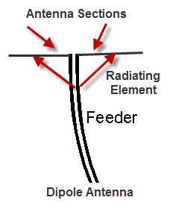](https://www.elprocus.com/wp-content/uploads/2014/07/dipole-antenna.jpg)

The dipole antenna consists of two metallic rods through which current and frequency flow. This current and voltage flow makes an electromagnetic wave and the radio signals get radiated. The antenna consists of a radiating element that splits the rods and make current flow through the center by using a feeder at the transmitter out that takes from the receiver.The different types of dipole antennas used as [RF antennas](https://www.elprocus.com/control-using-rf-communication/) include half wave, multiple, folded, non-resonant, and so on.

**Short-Dipole Antenna:**

[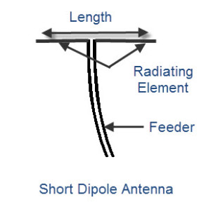](https://www.elprocus.com/wp-content/uploads/2014/07/short-dipole-antenna.jpg)Short Dipole Antenna

It is the simplest of all types of antennas. This antenna is an open circuited wire in which short denotes “ relative to a wavelength” so this antenna gives priority to the size of the wire relative to the wavelength of the frequency of operation. It does take any consideration about the absolute size of the dipole antenna. The short dipole antenna is made up of two co-linear conductors that are placed end to end, with a small gap between conductors by a feeder. A Dipole is considered as short if the length of the radiating element is less than a tenth of the wavelength.

**L<λ/10**

The short dipole antenna is made of two co-linear conductors that are placed end to end, with a small gap between conductors by a feeder.

The short dipole antenna is infrequently satisfactory from an efficiency viewpoint because most of the power entering this antenna is dissipated as heat and resistive losses also become gradually high.

**Monopole Antenna**

A monopole antenna is half of a simple dipole antenna located over a grounded plane as shown in the figure below.

[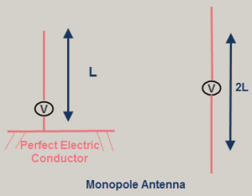](https://www.elprocus.com/wp-content/uploads/2014/07/monopole-antenna.jpg)The radiation pattern above the grounded plane will be same as the half wave dipole antenna, however, the total power radiated is half that of a dipole; the field gets radiated only in the upper hemisphere region. The directivity of these antennas become double compared to the dipole antennas.

The monopole antennas are also used as vehicle mounted antennas as they provide the required ground plane for the antennas mounted above the earth.

**Loop Antenna**

[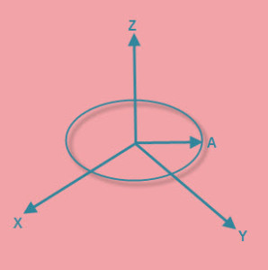](https://www.elprocus.com/wp-content/uploads/2014/07/loop-antenna.jpg)Loop Antenna

Loop antennas share similar characteristics with both dipole and monopole antennas because they are simple and easy to construct. Loop antennas are available in different shapes like circular, elliptical, rectangular, etc. The fundamental characteristics of the loop antenna are independent of its shape. They are widely used in communication links with the frequency of around 3 GHz. These antennas can also be used as electromagnetic field probes in the microwave bands.

The circumference of the loop antenna determines the efficiency of the antenna as similar to that of dipole and monopole antennas. These antennas are further classified into two types: electrically small and electrically large based on the circumference of the loop.

**Electrically small loop antenna———>  Circumference≤λ⁄10**

**Electrically large loop antenna  ———>    Circumference≈λ**

Electrically small loops of a single turn have small radiation resistance compared to their loss resistance. The radiation resistance of small loop antennas can be improved by adding more turns. Multi-turn loops have better radiation resistance even if they have less efficiency.

[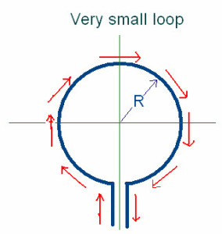](https://www.elprocus.com/wp-content/uploads/2014/07/small-loop-antenna.jpg)Small Loop Antenna

Due to this, the small loop antenna are mostly used as receiving antennas where losses are not mandatory. Small loops are not used as transmitting antennas due to their low efficiency.

Resonant loop antennas are relatively large, and are directed by the operation of wavelength .They are also known as large loop antennas as they are used at higher frequencies, such as VHF and UHF, wherein their size is convenient. They can be viewed as folded-dipole antenna and deformed into different shapes like spherical, square, etc., and have similar characteristics such as high-radiation efficiency.

### 3. Travelling Wave Antennas

**Helical Antennas**

Helical antennas are also known as helix antennas. They have relatively simple structures with one, two or more wires each wound to form a helix, usually backed by a ground plane or shaped reflector and driven by an appropriate feed. The most common design is a single wire backed by the ground and fed with a coaxial line.

In General, the radiation properties of a helical antenna are associated with this specification: the electrical size of the structure, wherein the input impedance is more sensitive to the pitch and wire size.

[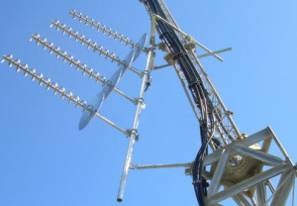](https://www.elprocus.com/wp-content/uploads/2014/07/helical-antenna.jpg)Helical Antenna

Helical antennas have two predominate radiation modes: the normal mode and the axial mode. The axial mode is used in a wide range of applications. In the normal mode, the dimensions of the helix are small compared to its wavelength. This antenna acts as the short dipole or monopole antenna. In the axial mode, the dimensions of the helix are same compared to its wavelength. This antenna works as directional antenna.

**Yagi-Uda Antenna**

[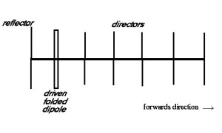](https://www.elprocus.com/wp-content/uploads/2014/07/yagi-antenna.jpg)Yagi-Uda Antenna

Another antenna that makes use of passive elements is the [Yagi-Uda antenna](https://www.elprocus.com/design-of-yagi-uda-antenna/). This type of antenna is inexpensive and effective. It can be constructed with one or more reflector elements and one or more director elements. Yagi antennas can be made by using an antenna with one reflector, a driven folded-dipole active element, and directors, mounted for horizontal polarization in the forward direction.

### 4. Microwave Antennas

The antennas operating at microwave frequencies are known as [microwave antennas](https://www.elprocus.com/introduction-to-types-of-microwave-antennas-in-communication-systems/). These antennas are used in a wide range of applications.

**Rectangular Micro strip Antennas**

[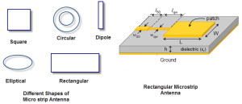](https://www.elprocus.com/wp-content/uploads/2014/07/patch-antenna.jpg)Rectangular Micro strip Antennas

For spacecraft or aircraft applications – based on the specifications such as size, weight, cost, performance, ease of installation, etc. – low profile antennas are preferred. These antennas are known as rectangular microstrip antennas or patch antennas; they only require space for the feed line which is normally placed behind the ground plane. The major disadvantage of using these antennas is their inefficient and very narrow bandwidth, which is typically a fraction of a percent or, at the most, a few percent.

**Planar Inverted-F Antennas**

A Planar Inverted-F Antenna can be considered as a type of linear Inverted F antenna (IFA) in which the wire radiating element is replaced by a plate to increase the bandwidth. The advantage of these antennas is that they can be hidden into the housing of the mobile when compared to different types of antennas like a whip, rod or helical antennas, etc. The other advantage is that they can reduce the backward radiation towards the top of the antenna by absorbing power, which enhances the efficiency. They provides high gain in both horizontal and vertical states. This feature is most important for any kind of antennas used in wireless communications.

### 5. Reflector Antennas

**Corner Reflector Antenna**

[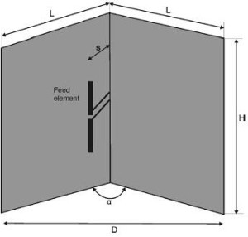](https://www.elprocus.com/wp-content/uploads/2014/07/corner-reflector-antenna.jpg)Corner Reflector Antenna

The antenna that comprises one or more dipole elements placed in front of a corner reflector, is known as corner-reflector antenna.The directivity of any antenna can be increased by using reflectors. In case of a wire antenna, a conducting sheet is used behind the antenna for directing the radiation in the forward direction.

**Parabolic-Reflector Antenna**

The radiating surface of a parabolic antenna has very large dimensions compared to its wavelength. The geometrical optics, which depend upon rays and wavefronts, are used to know about certain features of these antennas. Certain important properties of these antennas can be studied by using ray optics, and of other antennas by using electromagnetic field theory.

[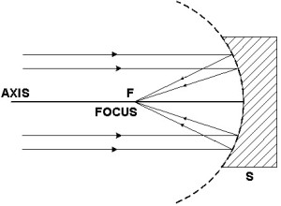](https://www.elprocus.com/wp-content/uploads/2014/07/parabolic-antenna.jpg)Parabolic Antenna

One of the useful properties of this antenna is the conversion of a diverging spherical wavefront into parallel wave front that produces a narrow beam of the antenna. The various types of feeds that use this parabolic reflector include horn feeds, Cartesian feeds and dipole feed.

In this article, you have studied about the different types of antennas and their applications in wireless communications and the usage of Antennas in transmitting and receiving data.  For any help regarding this article, contact us by commenting in the comment section below.